**Adding Google Drive to Microsoft Teams**

1. Open Microsoft teams and navigate to the Files tab located on the top. Click on Add Cloud Storage.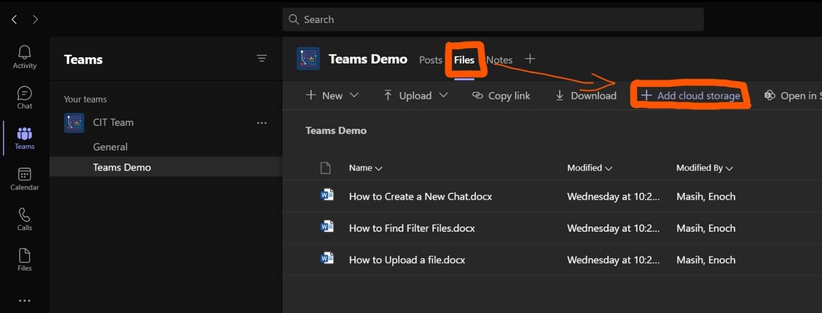
2. Select Google Drive. Login with your credentials and click **Allow.** This allows Microsoft teams to access your Google Drive. (Note- This is not allowing everyone to view your Google Drive, it is simply giving permissions to Microsoft Teams to access and make changes to your Google Drive.)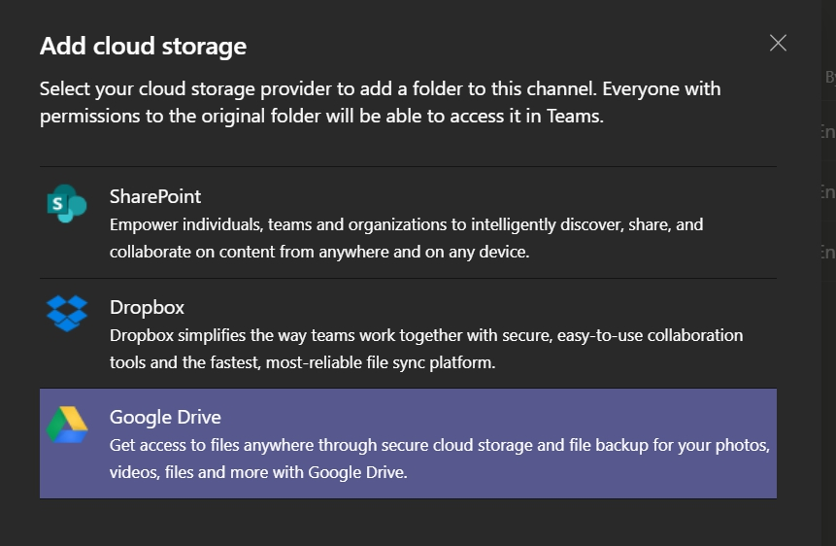
3. Select the particular folder from your Google Drive you would like to add to Microsoft Teams. Click Add folder. (Note- Only the contents of the selected folder will be added to Teams.)